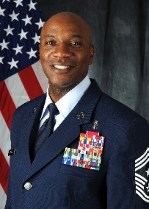
Nov 17, 2016
CSAF announces CMSAF #18
Air Force Chief of Staff Gen. David L. Goldfein named Chief Master Sgt. Kaleth O.
Wright to serve as the 18th Chief Master Sergeant of the Air Force Nov. 16, 2016.

Wright will assume his new position in February, following the retirement of Chief
Master Sgt. of the Air Force James A. Cody. Cody’s retirement culminates more
than 32 years of service to the Air Force.

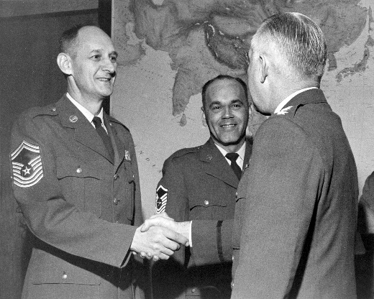
History lesson on the Chief Master Sergeant rank:

- Chief Master Sergeants weren't a part of the Air Force's enlisted structure when the service was formed in 1947.
- After the Korean War, the Air Force realized the enlisted corps suffered from stagnation in rank. Master sergeant was the highest enlisted rank a person could achieve.
- Congress enacted the Career Compensation Act of 1958 establishing the ranks we now know as Senior Master Sergeant and Chief Master Sergeant.
- The first promotions to CMSgt were effected 1 December 1959 when 620 Airmen were elevated to that rank.
- During the 1970s, Air Staff officials made "chief" the official term of address for an E-9.

The Role of the Chief Master Sergeant of the Air Force:

- Serves as the personal advisor to the SecAF and the CSAF on all issues regarding the welfare, readiness, morale, proper utilization and professional development of the enlisted force.
- Travels extensively to discuss AF concerns with Airmen and their families.
- Engages with military leadership and dignitaries of foreign nations regarding theater security cooperation and building partner capacity efforts.
- Represents the AF to the American public, professional organizations and the media.
- Consults with the Senior Enlisted Advisor to the CJCS and the Secretary of Defense on enlisted matters.
- Communicates with the force, testifies before Congress and meets with members in all levels of government to discuss AF issues and concerns.
- Serves on boards and committees for numerous organizations affecting Airmen.
November is Warrior Care Month
The Air Force Wounded Warrior Program supports each wounded Airman to provide a thorough analysis of opportunities and benefits that are available to medically retired and separated combat veterans.
For more information about the AFW2 program click here

►RESOURCES
Website access to the following resources can be gained by clicking on the name.

AF.mil

Airman magazine

Military OneSource/HomeFront

Air Force Personnel Center

Air Reserve Personnel Center

Department of Defense News

Department of Veteran Affairs

TRICARE

U.S. Government Website

Air Force Association Scholarships

Air Force Safety Center

Civil Service Employment Opportunities

NAF Employment Opportunities

Air Force Bands/Outreach

►THIS WEEK IN AIR FORCE HISTORY

Nov. 17, 1961 – The Air Force launched the first Minuteman missile from an underground silo at Cape Canaveral, Florida on a 3,000-mile flight down the Atlantic Missile Range.
Nov. 18, 1949 – An Air Force C-74 Globemaster, “The Champ,” flew from Mobile, Alabama to Marham, England in 23 hours. Carrying a record 103 passengers, it was the first trans-Atlantic flight to carry more than 100 passengers.
Nov 19, 2007 – In the War on Terrorism, the Air Mobility Command passed a major milestone when one of its aircraft flew the command’s one millionth sortie since September 11, 2001. A C-17 mission flown from McChord Air Force Base, Washington, to Manas Air Base, Kyrgyzstan, flew the landmark flight.
Nov. 20, 1963 – The Air Force accepted the first two F-4C fighters. They went to 4453rd Combat Crew Training Wing at MacDill Air Force Base, Florida.
Nov. 21, 1994 – Air Force and NATO aircraft bombed Serbian targets to retaliate for a Serbian attack on Bihac, Bosnia. The raid was the largest NATO operation to date.
Nov. 22, 1952 – While leading a flight of four F-80s against enemy gun positions in Korea, Maj. Charles J. Loring deliberately crashed his damaged aircraft into enemy gun emplacements. For that sacrifice, he was awarded the Medal of Honor.
Nov. 23, 2002 – The F/A-22 Raptor accomplished its first guided AIM-9M Sidewinder launch at 24,000 feet over the White Sands Missile Range, New Mexico, at Mach 1.4. The AIM-9 passed within lethal range of a QF-4 drone flying at Mach 1.

For more information on Air Force heritage, visit http://www.airforcehistory.af.mil

The Defense Media Activity produces Commander's Call Topics weekly. For questions or comments about
this or any other DMA product, send an e-mail to afbiographies.dma@mail.mil

Subscribe to AF news and information products, go to https://public.govdelivery.com/accounts/USDODAF/subscriber/new
►NOVEMBER BY THE NUMBERS

American Indian and Alaska Native Heritage Month
(Source: U.S. Bureau of the Census)

6.6 million | The nation’s population of American Indian and Alaska Native, including those of more than one race (about 2.0 percent of the total U.S. population) in 2015.
130,802 | The number of single-race American Indian and Alaska  Native veterans of the U.S. armed force in 2015
567 | The number of federally recognized American Indian tribes in 2016
326 | The number of federally recognized American Indian reservations in 2016
14.1 | The percentage of single-race American Indians and  Alaska Natives age 25 and older who had a bachelor’s, graduate of professional degree in 2015

